SOFTWARE REQUIREMENT ENGINEERING

SMART APPLIANCES

SRS DOCUMENT

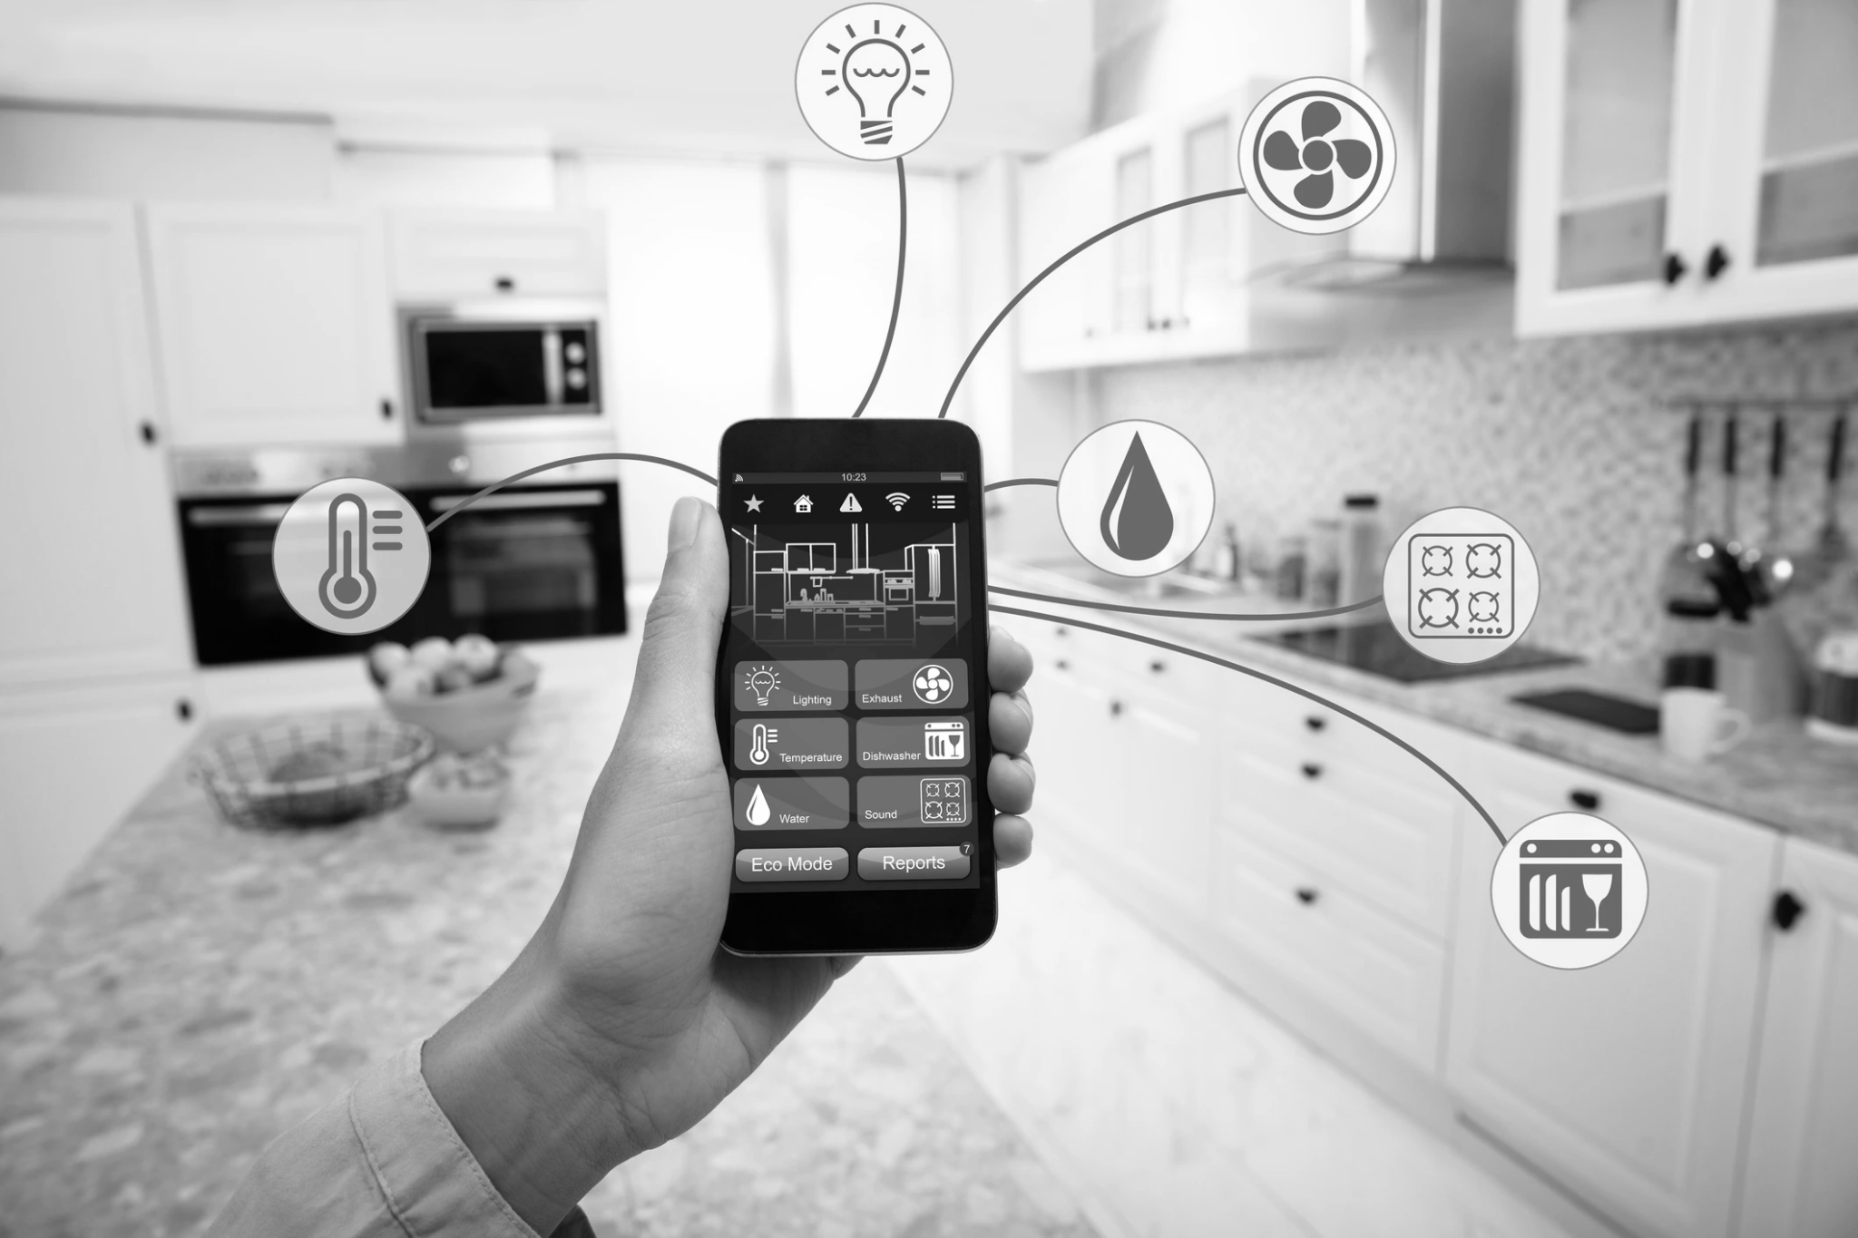

Contributed by:

Abdullah Imran

# Table of contents:

**Table of contents:** **2**

**1. Introduction:** **4**

1.1: Purpose 4

1.2: Document conventions 4

1.3: Project Scope 4

1.4: References 5

**2. Overall Description:** **6**

2.1: Product perspective 6

Our platform is designed to control the various appliances in homes and businesses, providing a centralized platform for controlling and monitoring various smart appliances. It also serves as an interface between the users and their connected appliances, providing them with tools to make controlling convenient, reliable, and secure. 6

2.2: User classes and characteristics 8

Favored user classes: 8

Disfavored user classes: 8

Ignored user classes: 9

Other user classes: 9

2.3: Operating Environment 9

Our system will operate in the following environment: 9

Hardware Platform: 9

OS versions: 10

Geographical locations of users: 10

Servers and databases: 10

Host websites: 11

2.4: Design and implementation constraints 11

2.5: Assumptions and dependencies 12

**3. System Features:** **13**

3.1: User Authentication: 13

3.2: Create Room: 14

3.3: Add appliances: 15

3.4: View Device analytics 16

3.5: Schedule appliances: 17

3.6: Register your company’s devices: 18

3.7: Schedule a policy meeting: 19

3.8: Make a payment: 20

3.9: Compile and send device reports: 21

3.10: Add other users: 22

3.11: Manage system settings: 23

3.12: Enable security mode: 24

**4. Data Requirements:** **26**

4.1: Logical Data Model 26

4.2: Data Dictionary 26

4.3: Reports 30

4.4: Data acquisition, integrity, retention, and disposal 31

**5. External interface requirements:** **32**

5.1: User interfaces 32

5.2: Software interfaces 34

5.3: Hardware interfaces 35

5.4: Communications interfaces 36

**6. Quality Attributes:** **37**

6.1: Usability: 37

6.2: Performance: 37

6.3: Security: 38

6.4: Safety: 39

**7. Internationalization and localization requirements:** **39**

**8. Other requirements:** **40**

**9. Appendix A: Glossary** **41**

System terminology: 41

Acronyms: 42

Definations: 42

**10. Appendix B: Analysis Models** **43**

Use case Diagram: 43

Activity Diagrams: 45

DFD 1: 57

# Introduction:

## 1.1: Purpose

The purpose of this SRS document is to clearly explain the requirements of the *Smart Appliances* platform, an advanced platform designed to provide a single point of access to all of your smart appliances that can be controlled via your computer. This system aims to enhance the comfort of our users, make it convenient for them to use their smart appliances, and help them make their smart appliances more efficient by enabling them to access and control them remotely and schedule their devices for a specific time.

This document is intended for various stakeholders involved in developing and implementing the *Smart Appliances* platform. Primarily, this document will be helpful for software developers, system architects, quality assurance teams, product managers, and product owners. But this can also be helpful for the clients, end-users, and marketing personnel to understand the system’s functionalities and requirements.

## 1.2: Document conventions

* **Heading levels:** This document follows a structured hierarchical form of heading levels that are numbered sequentially (Point 1, point 2, point 3, and so on) with sub-sections in them which are part of the particular major point (1.1, 1.2, 1.3, and on). This will help the reader navigate through the document easily and will help them to understand the relations between the particular point and its sub-sections.
* **Acronyms and Abbreviations:** In this document, we will be using the term “home users” or “first user” for the users who use the smart appliances in their homes, “business users” or “second user” for the users who use the smart appliances in their businesses, and “company users” or “third user” for the people who register their companies on our platform so that their smart appliances can be compatible with our platform. Furthermore, we will be using the word “smart appliances”, “appliances”, “devices” or “smart devices” for the smart appliances that will be used by our first and second users. We will not be using any particular notation or symbols in this document.

## 1.3: Project Scope

The project scope in our case is a platform that can automate your everyday appliances and make them convenient for our users via our platform. Our users can use the functionalities incorporated in our system to take full advantage of what they do with their appliances every day. This project aims to fulfill the following business and user objectives:

* **Enable Home Automation:** Our platform allows home users to control the various aspects of their homes, such as lighting, temperature, and security, and also helps them to manage their energy. This aligns with our objective of enhancing the user’s convenience, comfort, and energy efficiency in residential settings.
* **Support Business Operations:** Our platform caters to the everyday needs of business users by giving them tools to manage and control their appliances in commercial environments. It assists them while increasing their productivity and decreasing their energy expenses.
* **Facilitate Company Integration:** Our platform allows registered companies to integrate their smart appliances with our platform. This allows the other companies to increase their users, providing them the business opportunities and valuable data insights from our users.

## 1.4: References

Registration process analysis for company users:

<https://www.samsung.com/ca/support/apps-services/how-to-register-home-appliances-in-the-smartthings-app/>

[Home Connect: https://www.home-connect.co.nz/help-support/pairing-finder](https://www.home-connect.co.nz/help-support/pairing-finder)

Undestanding about home users via user manuals:

<https://smartliving.hkt.com/pdf/Smart_Living_Home_Automation_Solution_Samsung_Connect_App_User_Guide_v201907-eng.pdf>

<http://www.chnsmart.com/download/app_user_guide.pdf>

Sucess story in the rise of home appliances:

[A look into the future of smart home devices (gfk.com)](https://www.gfk.com/blog/a-look-into-the-future-of-smart-home-devices)

Increasing the business users via partnering:

[A value-based view of the smart PSS adoption: a study of smart kitchen appliances | SpringerLink](https://link.springer.com/article/10.1007/s11628-023-00529-9)

[Mapping the Smart-Home Market (bcg.com)](https://www.bcg.com/publications/2018/mapping-smart-home-market)

How going smart can help you:

[The Top 10 IoT Use Cases (iot-analytics.com)](https://iot-analytics.com/top-10-iot-use-cases/)

# 

# Overall Description:

## 2.1: Product perspective

## Our platform is designed to control the various appliances in homes and businesses, providing a centralized platform for controlling and monitoring various smart appliances. It also serves as an interface between the users and their connected appliances, providing them with tools to make controlling convenient, reliable, and secure.

**Origin and Context:**

*Smart Appliances* is developed as a standalone software product with an aim to make it accessible to our users via an application that can be installed on your computers such as PCs and smartphones. The system mostly interacts with a large range of smart appliances connected to it via wireless communication protocols. This is because the global industry now uses IoT-based devices through wireless communications as it is easier and more reliable.

The system operates within the users’ homes and businesses and thus provides them with centralized control for monitoring their smart appliances. We are designing it to be scaleable and adaptable to accommodate different types and brands of smart appliances, making it suitable for residential and commercial environments.

**Known Constraints, assumptions & Dependencies:**

* The system assumes that the user has a reliable internet connection to connect with the platform so that they can interact with their devices and control them remotely.
* The system depends on the availability and compatibility of the devices that can integrate with our system.
* The system is constrained by the limited network infrastructure and underlying limitations and specification of the hardware infrastructure from the users.
* The system assumes that the users will provide accurate information during the registration and setup of their devices.

**Context Diagram:**

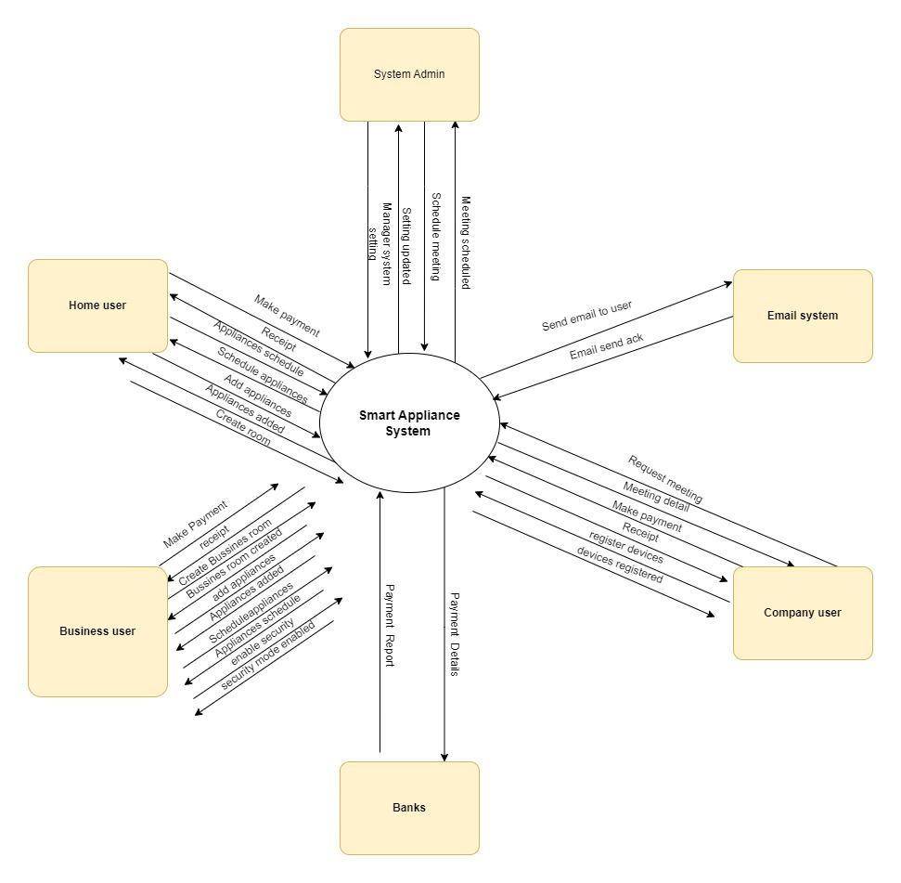

**Class Diagram:**

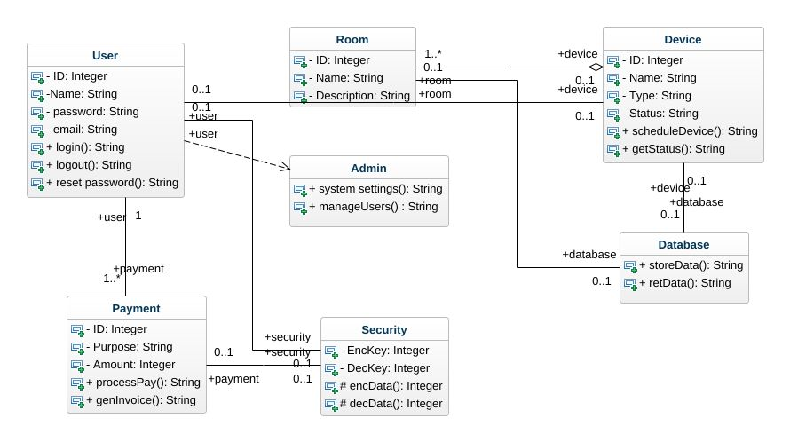

## 2.2: User classes and characteristics

### Favored user classes:

* **Home users:** These users represent the individuals who benefit from the convenience provided to them by *Smart Appliances* in their homes.
* **Business users:** These users represent the individuals who benefit from the various tools to control their appliances to manage their energy consumption and optimize operational efficiency in a commercial environment.
* **Company Users:** These individuals represent the companies who wish to broaden their user base by registering their appliances on our platform to be able to make their devices compatible with our platform.
* **Main stakeholders:** These individuals represent the entities that have a vested interest in the success of the *Smart Appliance* platform.

### Disfavored user classes:

* **Hackers and security breachers:** These individuals are the ones who have the intent to harm the system and breach its security for their own interests.

### Ignored user classes:

* **Application visitors:** The individuals who visit the platform to see what it is without engaging in the use of the system and its features.
* **Non-paying users:** These individuals do not contribute to the revenue generation of the platform and hence are ignored by the system.
* **Users who need to be made aware of technology:** These individuals might not have knowledge of the system and how it works and are likely not to own any smart appliances of their own.

### Other user classes:

* **System admins:** These users are the ones who have the necessary privileges to change the system’s settings, configurations, and user management.
* **Banks:** These users are the ones who process the payments that are made by the first, second, and third users and store them in their database.

## 2.3: Operating Environment

## Our system will operate in the following environment:

### Hardware Platform:

The system requires a robust infrastructure to handle the user interactions with the system and process the data efficiently. This is because the system is repeatedly communicating with the devices to retrieve their data and apply certain settings on those devices as per the user’s settings. The hardware platforms include high-performance servers with sufficient power processing, memory, and storage capacity. We plan to install the following hardware:

**Dell Power Edge R740:** This server is powered by two Intel Xeon E5-2697 v4 processors, with a base frequency of 2.3GHz and a maximum turbo boost of 3.6 GHz. It also has 128GB of DDR4 ECC memory and 4TB of SAS 7.2k RPM hard drives and also has 24 cores, 128GB of RAM, and 4TB of storage. This can be very powerful for our system as we need good processing power.

**IBM System x3650 M5:** This server has 12 cores, 96GB of RAM, and 3TB of storage. Additionally, it is powered by two Intel Xeon E5-2667 v4 processors, which have a base frequency of 2.2 GHz and a maximum Turbo Boost frequency of 3.3 GHz. The server also has 96GB of DDR4 ECC memory and 3TB of SAS 10k RPM solid-state drives. It is a good choice for our system since we require a high level of reliability and security.

### OS versions:

For IBM System x3650 M5:

* Server-Side OS: IBM AIX, Red Hat Enterprise Linux (RHEL), SUSE Linux Enterprise Server (SLES), Microsoft Windows Server, VMware ESXi
* Client-Side OS: Microsoft Windows (various versions), macOS, Linux distributions (such as Ubuntu, Fedora, CentOS), mobile operating systems (iOS, Android). The version of Windows should be version 7 at least and Mac OS X 10.7 for MacOS. The iOS version should be at least iOS 8 and the Android version must be Android 7.

For Dell PowerEdge R740:

* Server-Side OS: Microsoft Windows Server, Red Hat Enterprise Linux (RHEL), SUSE Linux Enterprise Server (SLES), VMware ESXi
* Client-Side OS: Microsoft Windows (various versions), macOS, Linux distributions (such as Ubuntu, Fedora, CentOS), mobile operating systems (iOS, Android). The version of Windows should be version 7 at least and Mac OS X 10.7 for MacOS. The iOS version should be at least iOS version 8 and the Android version must be at least Android 7.

### Geographical locations of users:

Our business model is initially designed to cover the major cities of Pakistan only but as we expand our businesses, we will be moving to other geographical locations too. Hence, we will restrict the users to Pakistan initially but that won’t mean that our hardware and software will work in Pakistan only but they will be able to work globally too.

### Servers and databases:

The system utilizes the following servers and databases:

* Web Server: Apache HTTP Server
* Application Server: Node.js
* Database Server: MySQL 8.0

### Host websites:

**Amazon Web Services (AWS):** AWS offers a variety of services for hosting websites, including Elastic Beanstalk, CloudFront, and Route 53.

**Microsoft Azure:** Azure offers a variety of services for hosting websites, including App Service, Traffic Manager, and Azure Front Door.

**Google Cloud Platform (GCP):** GCP offers a variety of services for hosting websites, including App Engine, Cloud CDN, and Cloud Load Balancing.

We plan to include at least one of them or all of them in our system. We can use GCP as our host website since it provides us with scalability, reliability, availability, and security and since it is also very popular and we already have some understanding related to Google and their platform.

## 2.4: Design and implementation constraints

* Technology Stack: The system must be developed using Java as the primary programming language and utilize frameworks like Django for backend development. This constraint will ensure that the consistency and compatibility with existing technology infrastructure are ascertained. These frameworks are also used widely in the market and hence it will be easier for us to maintain them in the future.
* Integration with Existing Systems: The system needs to integrate with external systems, such as payment gateways or third-party APIs, restricting it to specific integration protocols and data formats. This constraint will also ensure seamless data integration with external systems.
* Security Requirements: The system must adhere to industry-standard security practices, such as the encryption of sensitive user data, securing user authentication, and protection against common security threats. This constraint will ensure the confidentiality, integrity, and availability of user information and lessen the risk of unauthorized access or data breaches.
* Performance and Scalability: Smart appliances platform must be designed to handle a large number of repeated users and ensure optimal performance so that there is no unavailability in the system which can further lose our customers. This will involve implementing caching mechanisms, database optimization techniques, and scalable infrastructure such as load balancing and auto-scaling.
* Budget and Resource Limitations: The development and implementation of our system should be aligned with the allocated budget and available resources. This constraint requires efficient utilization of resources, careful planning, and prioritization of features and functionalities to avoid problems in the future.
* Compatibility with Operating Systems: The system should be compatible with major operating systems such as Windows and MacOS which most of the market uses so that we can target as many users as possible. This constraint may involve conducting compatibility testing and addressing platform-specific considerations during the development phase.
* Usability and Accessibility: The system needs to make sure that usability and accessibility guidelines are ensured to provide a user-friendly experience for a diverse range of users. This includes considerations for easy-to-use user interfaces, clear navigation of the UI, and compliance with accessibility standards.

## 2.5: Assumptions and dependencies

**Assumptions:**

* **Internet Connectivity:** It is assumed that the users using the platform have a stable connection to the Internet so that they can use their smart appliances without any hassle.
* **Adequate hardware resources:** It is also assumed that the hardware devices used by the users such as PCs or the smartphone meet the minimum system requirements to access and utilize the system’s functionalities seamlessly.
* **User’s familiarity with computing skills:** It is assumed that the user using the system has enough knowledge to be able to use the system for its intended functionalities and can also understand what the system demands from the user in order to use the particular function.
* **Compliance with applicable laws and regulations:** It is assumed that the system will be as per the underlying laws related to the user’s privacy, security, and intellectual property rights.

**Dependencies:**

* **OS compatibility:** The application depends upon compatibility with a specific OS. It assumes that the app will run without major bugs and issues within in the OS.
* **Third-party libraries or frameworks:** Our platform relies upon third-party libraries or frameworks for specific functionalities such as user authentication, data storage, or user interface components. The working of these libraries is essential for the seamless working of our platform.
* **DBMS:** The application will depend upon several database management systems to store the data in an efficient manner. These DB should be properly configured and installed for long-term use.
* **System updates and patches:** The application will depend upon periodic updates, performance bugs, and other bugs fixes by the developers, including the new features as per the demand, and timely issuance of the mentioned things in order to keep the platform as per the industry standard and free from bugs.

# System Features:

### 3.1: User Authentication:

* **Description:** Enable the user to successfully log in and log out of the application securely.
* **Priority:** High
* **Functional requirements:**
  + **FR-01: User Authentication:**
    - System must verify email & passwords against the stored credentials.
    - The user must be granted access to the system if the provided credentials are valid.
    - If the provided credentials are invalid, the error message is displayed and the user is told to log in once again.
  + **FR-02: Account Creation:**
    - If the user does not have an account already, they will be able to create a new account.
    - The system will validate the information such as the name, email, contact no, and password.
    - If the information is valid, the account will be created and the user will be able to use the platform.
  + **FR-03: Password reset:**
    - If the user forgets their password, they will be able to reset their password.
    - The system will prompt the user to enter their email address.
    - A password reset link will be sent to the user’s email address.
    - The user will follow the link and set a new password.
* **Error Handling:**
  + If the user enters the wrong email and password, an error message will be displayed telling the user to re-enter their credentials.
  + If the user enters incomplete information during the sign-up process, an error message will be displayed telling the user to enter the complete information.
* **Invalid inputs and actions:**
  + If the user enters an invalid email address, the error message will be displayed telling the user to provide a valid email address.
  + If the user attempts to log in via an unverified account, the error message will be displayed telling the user to verify their email before logging in.

### 3.2: Create Room:

* **Description:** This feature enables home and business users to create rooms within the smart home system. Users can organize their devices by assigning them to specific rooms. Each room is independent, and devices added to one room cannot be accessed from other rooms. Users can create multiple rooms and later add devices to them. The created rooms provide a structured view of devices within the platform.
* **Priority:** Medium
* **Functional requirements:**
  + **FR-05: Room Creation:**
    - The system should provide the UI for creating a room.
    - The user must be able to enter the room details such as the room name and the optional description.
    - After this, the system will create a new room associated with the user’s account.
* **FR-06: Room Management:**
  + The system should allow the users to modify the room details such as the room name and the description.
  + Users should also be able to delete the rooms.
* **FR-07: Device association:**
  + After creating the room, the user will be able to add devices into that room.
* **Error Handling:**
  + If there is a technical issue while creating a new room, the system will display an error message telling the user to try again later.
* **Invalid inputs and actions:**
  + If the user provides an invalid room name such as a space character only or no character, the system will tell the user to enter a valid name.

### 3.3: Add appliances:

* **Description:** This feature allows Home Users and Business Users to add devices or appliances to the rooms they have created within the smart appliance platform. Devices can be added to rooms either by scanning a QR code provided on the device or through a manual process that requires entering device details such as name, a unique number associated with that device, and company information. Devices added to a specific room can only be accessed and controlled within that particular room.
* **Priority:** Medium
* **Functional requirements:**
  + **FR-07: Device addition:**
    - The system should provide a UI within the device management system for the user to be able to add a device within a room.
    - The user will have the option to add devices via QR code scanning or manual entry.
* **FR-08: QR Code Scanning:**
  + If the user will choose the QR code scanning option, the system should allow the user to add their device via scanning the code behind their device using their computer’s camera
  + The system should retrieve the information of the device via scanned QR code and validate its compatibility with the platform.
  + The system will associate the device with the room and update the UI to reflect the addition.
* **FR-09: Manual entry:** 
  + If the user chooses the manual scanning option, the system should provide the fields such as name, unique number, and company name of the device to the user.
  + The system should validate the information and check for the device’s compatibility with the platform.
  + The system will associate the device with the room and update the UI to reflect the addition.
* **Error Handling:**
  + If the scanned QR is unrecognized, the system should display a message to the user indicating that the device’s QR code is unrecognized or is incompatible with the platform.
  + If there is a technical issue such as a network issue, the system should display a message to retry later.
* **Invalid inputs and actions:**
  + If the user enters incomplete or wrong information during the manual entry process, the system should display a message telling the user that the fields must be entered correctly.

### 3.4: View Device analytics

* **Description:** This use case allows Business Users and Home Users to view detailed analytics and information about their registered devices. By accessing the platform's device analytics feature, users can monitor various aspects of their devices, including energy consumption, scheduled timings, device status, error logs, and other relevant data. This information helps users make informed decisions regarding device usage and identify any issues.
* **Priority:** Medium
* **Functional Requirements:**
  + **FR-10: Device analytics access:**
    - The system must provide a UI for the user to be able to access their device’s analytics.
    - The user should b able to select the room and device for which they want the information.
  + **FR-11: Device analytics display:**
    - After the user selects a particular room, they must be displayed with multiple options including to display of the device’s analytics.
    - The system will retrieve the information related to the device such as its energy consumption, scheduled timings, device’s status, error logs (errors of the device with description), usage statistics (frequency of usage, peak time usage, etc.)
  + **Error Handling:**
    - If the user has not selected any room or device, the message will be displayed telling the user to select a room or device.
    - If there is no device data, the system should display a message telling the user that there is no data currently available.
    - If there is a technical issue while retrieving the device’s information, the system will prompt the user to try again later.
  + **Invalid inputs and actions:**
    - If the user selects or tries to select a non-existent room or device, the system will display the message indicating the error.

### 3.5: Schedule appliances:

* **Description:** This feature allows homes and business users to schedule their appliances within the system. The users can enter specific time intervals for turning the appliances on or off at that specific time, providing convenience and energy savings for the users.
* **Priority:** Medium
* **Functional Requirements:**
  + **FR-13: Schedule appliance access:**
    - The system should provide the UI for accessing the scheduling feature within the device management area.

* **FR-14: Scheduling appliance configuration:**
  + The user should first select the particular room, then the deice in that room to be able to schedule it.
  + The user will select the option to “schedule appliance”.
  + The system will display a window to the user telling them to enter the desired time for the device’s activation and de-activation.
  + After entering the time slots, the user will click on “OK”.
  + The system will tell the user that the particular device has been scheduled between [start time] and [end time].
* **Invalid inputs and actions:**
  + If the user enters an invalid time, the system will dispaly an error message indicating to re-enter the time. The user will re-enter the time and then the system feature will continue further.
* **Error Handling:**
  + If there is a technical issue such as internet connectivity issue, the system will display the message to the user telling them retry later.

### 3.6: Register your company’s devices:

* **Description:** This use case allows company users to register their devices with our platform. Company users will provide information about their company, main stakeholders, and the devices they want to register. The registration process also includes the payment of the registration fee. Company users can register multiple devices, with a maximum limit of 10, before the policy meeting is held.
* **Priority:** Medium
* **Functional requirements:**
  + **FR-16: Access Device Registration:** 
    - The system should provide a UI for registering the company’s devices.
    - The company user must have a valid account on the platform.
* **FR-17: Company Device information:**
  + The company user should be able to enter the name of their company’s name and the names of their organization’s head and titles.
  + The company user will enter the names, specs, and descriptions of the devices that they want to register with us.
  + The company user will only select the 10 devices they want to register.
* **FR-18: Registration Fee and Payment:**
  + The company user will use the integrated payment methods to make a payment before their devices can be registered and a policy meeting can be held up. (Part of making a payment feature)
* **Error Handling:**
  + If the company user tries to register more than 10 devices at a time, the system should display an error message telling the user that a maximum of 10 devices can be registered at a time.
  + If the company user’s balance is less than the fee, the system will display the message “insufficient balance”.
* **Invalid inputs and actions:**
  + If the user enters incomplete information, the system should display a warning message telling the user to enter complete information.

### 3.7: Schedule a policy meeting:

* **Description:** This feature allows the System Admin to schedule a policy agreement meeting with the Company Users within the smart appliance platform. The meeting is intended to discuss and finalize policy agreements between the platform stakeholders and the company users such as the profit margins, sales, etc.
* **Priority:** Medium
* **Functional Requirements:**
  + **FR-19: Access Meeting Scheduling:**
    - The system should provide the system admin with the UI to be able to schedule a policy meeting.
    - The system admin must be logged in before using this feature.
* **FR-20: Meeting details and agenda:**
  + System admin should be able to enter the meeting details such as time and date, duration, and agenda.
  + The agenda should cover the topics to be discussed during the meeting.
* **FR-21: Select Attendees:** 
  + The system admin should be able to select the company users who should attend the meeting.
* **FR-22: Submit scheduling request:**
  + The system admin should be able to submit the meeting details and send the meeting request.
  + Upon submission, the system should send the meeting details to the company users via email.
* **Error Handling:**
  + If the system admin enters the incorrect time or date, the error must be displayed to the system admin telling them to re-enter the details.
* **Invalid inputs and actions:**
  + If the system admin tries to submit the request without entering the meeting details, the system will display an error and will prompt them to enter the meeting details to proceed.

### 3.8: Make a payment:

* **Description:** This feature allows the home, business, and company users to be able to make a payment to be able to access the system and its features for home and business users and to be able to register devices for company users. Banks will be able to process the payments.
* **Priority:** High
* **Functional Requirements:**
* **FR-23: Access Payment Option:**
  + The system should provide a UI for accessing the payment option.
  + The user must be registered and logged into the app before initiating this feature.
* **FR-24: Display payment details:**
  + The system should be able to display payment details such as date, the amount paid, etc.
* **FR-25: Payment information:**
  + The user should be able to provide the payment information such as credit card details, bank account number, name, etc.
* **FR-26: Submit payment request:**
  + The user should be able to confirm the payment details and submit a payment request.
* **FR-27: Update payment status:**
  + Upon successful payment, the system should update the payment status and grant access to the platform to the user.
* **FR-28: Generate payment confirmation:**
  + The system should generate a payment confirmation and display it to the user.
  + The user should receive the payment confirmation via their registered email address.
* **Error Handling:**
  + If the user’s payment is declined, the system should display a message to the user telling them that their payment has been declined.
  + If there is any technical issue going on with the payment processing or the bank connection, the system should display a message to the user telling them to try again later.

### 3.9: Compile and send device reports:

* **Description:** This feature allows the System Admin to compile and send device reports to the registered Company Users of the smart appliance platform. The reports contain information about the usage of the Company Users' devices by the platform's users, including the number of users using the devices, the specific devices being used, the efficiency of these devices, any reported complaints, a comparison of device popularity with the previous month, and general usage patterns. The reports are automatically generated by the system and emailed to the respective Company Users.
* **Priority:** Medium
* **Functional Requirements:**
* **FR-29: Access administrative section:**
  + The system admin must have access to the administrative section to initiate the feature.
* **FR-30: Select Company User:**
  + The system admin should be able to select from the list of registered company users to generate the report.
* **FR-31: Compile device report:**
  + The system should automatically compile the device reports for the specific company user based on the available data.
  + Report should include the number of people using the company’s devices, a list of the devices being used, device efficiency metrics, device’s popularity over the last month, and the general usage patterns of the devices.
* **FR-32: Send report via email:**
  + The system should send the compiled report to the registered company user via their registered email address.
* **Error Handling:**
  + If there are no registered company users in this feature, the system should display the message indicating this, and in this case, the feature will terminate.
  + If there is a technical issue with compiling the report or email delivery, the system should log the error and send the device report later.

### 3.10: Add other users:

* **Description:** This feature enables Home Users and Business Users to add other users and grant them access to control their respective homes or business appliances. By adding other users, the primary users can share the platform's functionalities and allow additional individuals to manage devices, create new rooms, and utilize various features. The added users will receive login credentials via email and can log in to the platform to access and control the authorized devices.
* **Priority:** Medium
* **Functional Requirements:**
  + **FR-33: Access Account Settings:**
    - The primary user should be able to access the account settings on the platform to be able to initiate this process.
* **FR-34: Add other users:**
  + The primary users should be able to select the other users they wish to give access to.
* **FR-35: Enter email address:**
  + The system should prompt the primary user to add the email address of the users they wish to add.
* **FR-36: Verify Email address:**
  + The system should verify the email dresses provided to see if they are valid or not.
* **FR-37: Send login credentials:**
  + If the added user already has an account on the platform, they will be sent a link via email through which they will be added to the particular home or business.
  + If the added user does not have an account on the platform, they will be sent with temporary usernames and passwords via email. Then they will be added to a particular home or business upon successful login. After that, they can create their account on the platform and use that username and password to access the home/business.
* **FR-38: Access and Utilize platform:**
  + The added users will be able to access the platform with their credentials.
  + The added users can navigate through a particular home/business and manage its settings, see the device info, etc.
* **Error Handling:**
  + If the provided emails are not properly formatted or are invalid, the system will display an error indicating the user to provide a valid email address.
  + If there is a technical issue with the email delivery, the system will display an error message telling the user to try again later.

### 3.11: Manage system settings:

* **Description:** This feature allows the System Admin to manage the system settings of the smart appliance platform. The System Admin can update settings related to user subscriptions, device registration, and other system configurations. The settings are automatically updated based on payment status and user actions, but the System Admin can also manually adjust them if needed.
* **Priority:** Medium
* **Functional requirements:**
  + **FR-39: Access system admin panel:**
    - System admin should be able to access the system admin’s panel to initiate or use this feature.
* **FR-40: Manage system settings:**
  + System admin can select the option to manage the settings from their panel.
* **FR-41: Display settings:**
  + The system should display the list of settings for the system admin to manage.
* **FR-42: Modify the user subscription settings:**
  + The system admin can modify the user’s subscription settings based on their payments.
  + The system admin will be able to block the user’s access to the platform if they fail to pay the monthly subscription fee.
* **FR-43: Modify device registration settings:**
  + The system admin can update the registration status based upon the payment of the registration by the company user.
  + System admin will not register the company user unless they pay their subscription fee.
* **Modify other system settings:**
  + The system admin can also modify either system setting such as user limits, device compatibility, and general platform behavior.
* **Error Handling:**
  + If there is an error during the settings change or system failure, the system should display a message telling them to seek technical assistance.

### 3.12: Enable security mode:

* **Description:** This feature allows Business Users to enable the Security Mode on the smart appliance platform, enhancing the security measures for their account and data. By enabling Security Mode, Business Users can enforce additional security measures such as two-factor authentication (2FA) and password requirements. Enabling Security Mode also ensures that their user data is not collected by the system.
* **Priority:** Medium
* **Functional requirements:**
  + **FR-44: Access Account settings:**
    - The business user should be able to access their account settings within the platform.
* **FR-45: Enable security mode:**
  + The business user should be able to enable the security mode from the account settings.
* **FR-46: Enforce 2FA:**
  + When the security mode is enabled, the system enforces 2FA for each login attempt made by the business user.
  + The business user will enter their password along with the verification code that they have received via their email address.
* **FR-47: Enforce password requirement:**
  + Upon enabling security mode, the system will ask for a password each time the business user logs in.
* **FR-48: Disable data collection:**
  + Upon enabling the security mode, the system disables the data collection from the business user’s devices.
  + The business user’s data is not recorded or stored by the system.
* **Error Handling:**
  + If there is a technical issue or system error while enabling the security mode, the system will display an error message to the business user telling them to try again later.

# Data Requirements:

## 4.1: Logical Data Model

Following is an ERD for our system:

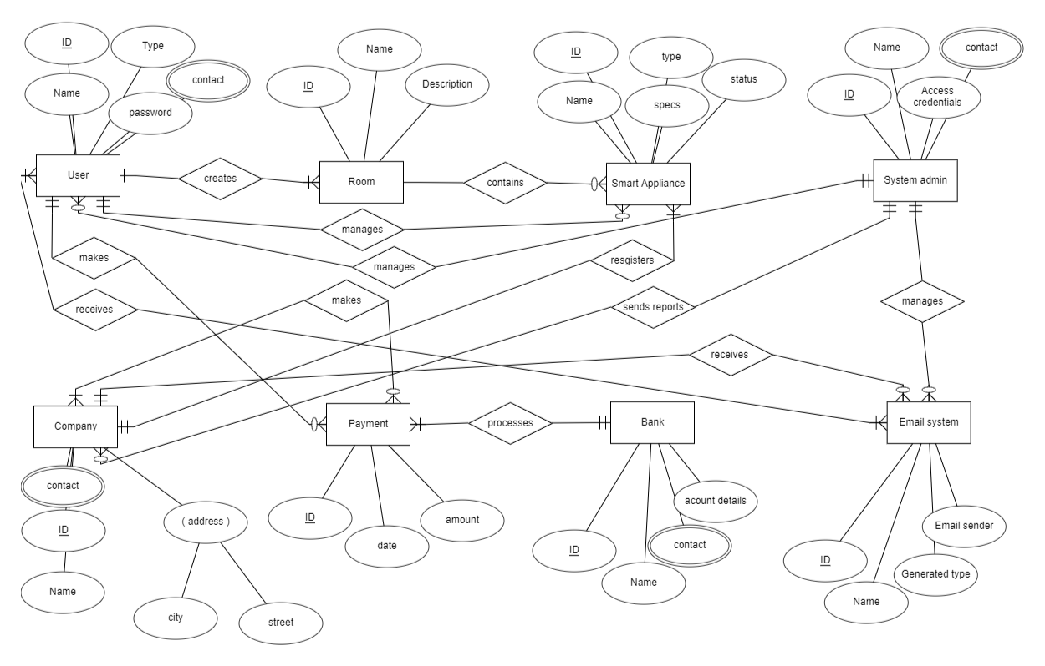

## 4.2: Data Dictionary

1. **User ID**

• Description: Unique identifier for each user in the system.

• Data Type: Numeric

• Length: 10 characters (example: "U123456789")

• Format: N/A (no specific format required)

• Allowed Values: Alphanumeric characters

2. **Full Name**

• Description: The full name of a user.

• Data Type: Text

• Length: 100 characters

• Format: N/A

• Allowed Values: Any text input

3. **Email**

• Description: The email address of a user.

• Data Type: Text

• Length: 255 characters

• Format: Valid email format (e.g., "example@example.com")

• Allowed Values: Valid email addresses

4. **Password**

• Description: User's password for authentication.

• Data Type: Text

• Length: 50 characters

• Format: N/A

• Allowed Values: Any text input (passwords should be encrypted/hashed for storage)

5. **Contact Number**

• Description: User's phone number.

• Data Type: Numeric

• Length: 15 characters

• Format: N/A

• Allowed Values: Numeric characters (including country code)

6. **Address**

• Description: User's residential or business address.

• Data Type: Text

• Length: 255 characters

• Format: N/A

• Allowed Values: Any text input

7. **Company Name**

• Description: Name of the user's company.

• Data Type: Text

• Length: 100 characters

• Format: N/A

• Allowed Values: Any text input

8. **Device Name**

• Description: Name or identifier of a device.

• Data Type: Text

• Length: 50 characters

• Format: N/A

• Allowed Values: Any text input

9. **Device Specifications**

• Description: Detailed specifications of a device.

• Data Type: Text

• Length: 400 characters

• Format: N/A

• Allowed Values: Any text input

10. **Device Status (On/Off)**

• Description: Current status of a device (on or off).

• Data Type: Text

• Length: 3 characters

• Format: N/A

• Allowed Values: "On" or "Off"

11. **Device Energy Consumption**

• Description: The energy consumption of a device.

• Data Type: Numeric (decimal)

• Length: N/A

• Format: N/A

• Allowed Values: Positive decimal numbers

12. **Device Schedule**

• Description: The schedule or timing for operating a device.

• Data Type: Text/Time

• Length: Unlimited

• Format: N/A

• Allowed Values: Any text input representing a schedule

13. **Device Errors/Alerts**

• Description: Errors or alerts related to a device's operation or status.

• Data Type: Text

• Length: Unlimited

• Format: N/A

• Allowed Values: Any text input describing errors or alerts

14. **Meeting Date**

• Description: The date of a meeting.

• Data Type: Date

• Length: N/A

• Format: DD-MM–YYYY

• Allowed Values: Valid date format

15. **Meeting Attendees**

• Description: The list of attendees/participants for a meeting.

• Data Type: Text

• Length: Unlimited

• Format: N/A

• Allowed Values: Any text input representing attendees' names or identifiers

16. **Meeting Agreements/Policies**

• Description: Agreements or policies discussed or decided in a meeting.

• Data Type: Text

• Length: 3000 characters

• Format: N/A

• Allowed Values: Any text input describing agreements or policies

17. **Payment Amount**

• Description: The amount of payment.

• Data Type: Numeric (decimal)

• Length: N/A

• Format: N/A

• Allowed Values: Positive decimal numbers

18. **Payment Status**

• Description: The status of a payment (e.g., pending, completed, failed).

• Data Type: Text

• Length: 20 characters

• Format: N/A

• Allowed Values: Any text input representing payment statuses

19. **Report Data (Usage Statistics, Device Popularity, Complaints, etc.)**

• Description: Data collected for generating reports (usage statistics, device popularity, complaints, etc.).

• Data Type: Text

• Length: Unlimited

• Format: N/A

• Allowed Values: Any text input representing report data

20. **Report Frequency**

• Description: The frequency at which reports are generated (e.g., daily, weekly, monthly).

• Data Type: Text

• Length: 20 characters

• Format: N/A

• Allowed Values: Any text input representing report frequencies

21. **Report Format**

• Description: The format in which reports are generated (e.g., PDF, CSV, HTML).

• Data Type: Text

• Length: 10 characters

• Format: N/A

• Allowed Values: Any text input representing report formats

22. **Room Name**

• Description: The name or identifier of a room.

• Data Type: Text

• Length: 50 characters

• Format: N/A

• Allowed Values: Any text input

23. **Room Devices**

• Description: The list of devices present in a room.

• Data Type: Text

• Length: Unlimited

• Format: N/A

• Allowed Values: Any text input representing device names or identifiers

24. **User Access Rights/Permissions**

• Description: The access rights or permissions granted to a user.

• Data Type: Text

25. **System Settings (Security Mode, 2FA, Password Requirements, etc.)**

• Description: Various settings related to the system configuration and security.

• Data Type: Text/Boolean/Enumerated

• Length: N/A

• Format: N/A

• Allowed Values:

1. Security Mode: Text (e.g., "Standard," "Enhanced," "Custom")

2. 2FA (Two-Factor Authentication): Boolean (true/false)

3. Password Requirements: Text (e.g., "Minimum 8 characters, at least one uppercase letter, one lowercase letter, one digit")

## 4.3: Reports

**Report Name:** Usage and Complaints Report

**Purpose:** To provide company users with a summary of usage statistics and complaint information.

**Content:** The report includes the following data:

* **Usage statistics:** Information on device usage, energy consumption, and any relevant metrics.
* **Complaints:** Details of user complaints, including the type of complaint and its resolution status.

**Format:** PDF (Portable Document Format)

**Layout:** The report is designed with clear sections and visual representations (if applicable) for easy understanding.

**Filters and Parameters:** The report can be filtered based on specific criteria, such as date range, device type, or complaint category.

**Frequency:** Monthly basis (generated every 30 days)

**Recipients:** Company users (specified recipients within the company)

**Delivery Method:** Email delivery in PDF format

## 4.4: Data acquisition, integrity, retention, and disposal

* **Data Acquisition:**

Data in the system is acquired through multiple sources, including:

* **User Input:** Users provide data such as their personal information, device schedules, meeting details, and meeting agreements.
* **Device Setup:** Devices connected to the system may provide data on their specifications, status, energy consumption, and errors/alerts.
* **Configuration of the Device:** Configuration settings of devices, such as security mode or password requirements, contribute to the system's data.
* **Automated Data Collection:** The system may automatically collect data, such as usage statistics, device popularity, and complaints, at regular intervals.
* **Other sources:** Data acquisition methods may also include user interaction with the application, API calls to external systems for retrieving relevant information, and real-time data streaming from smart devices.
* **Data Integrity Requirements:**

To protect the integrity of the system's data, the following requirements should be considered:

* **Data Validation:** Implement mechanisms to validate the accuracy, completeness, and consistency of data at input points.
* **Access Controls:** Employ role-based access controls and user permissions to prevent unauthorized modifications.
* **Checksums:** Checksums or hash functions may be used to validate data integrity during data transmission or storage.
* **Error Handling:** Error handling mechanisms should be be in place to address data integrity issues, such as logging and reporting errors, and implementing appropriate error correction or data recovery processes.
* **Data Encryption:**

Use encryption techniques to secure sensitive data both during transmission and storage.

* **Audit Trails:** We shall maintainthe audit trails to track changes made to the data and identify potential integrity breaches.
* **Error Handling:** Implement error handling mechanisms to detect and correct data integrity issues promptly.
* **Data Retention and Disposal:**
  + *Smart Appliances* will adhere to data retention policies to determine the storage duration of different types of data.
  + User-related data, such as preferences, device configurations, and automation rules, will be retained as long as the user remains active on the platform.
  + Cached data is regularly refreshed and cleared to maintain data currency and optimize platform’s performance.
  + Archived data, such as historical usage logs or system event records, may be retained for a specified period to support analysis and auditing purposes.
  + When data is no longer needed or upon user request, appropriate procedures will be followed to dispose of the data securely, ensuring compliance with local and global privacy regulations. Data that has exceeded the duration for what it was meant to be kept originally is identified and then disposed off.
  + Secure data disposal will involve techniques such as data wiping, shredding, and cryptographic deletion to prevent unauthorized access or recovery of the data.
  + Our system will also ensure that all copies of the data, including backups or cached copies, are securely removed from storage devices.

# External interface requirements:

## 5.1: User interfaces

**1. Logical Characteristics:** Our system will have UI that provides intuitive controls and a user-friendly interface. This comes from one of our key requirements from our home and business users during the requirement elicitation phase. The interfaces will be designed to meet the specific needs of the users as per the industry standards.

**2. References to UI Standards:**

We will be following the specific industry user interface standards for smart home automation applications and ensure intuitive controls and user-friendly interfaces. References such as the SmartThings Developer Documentation or Apple's Human Interface Guidelines for HomeKit can also be taken into account during the development.

**3. Standards for Fonts, and Icons**

We will implement a consistent visual style across user interfaces. Appropriate button labels and high-quality visuals and pictures shall be included while keeping in mind copyright issues. For this, we would use a font that is similar to Robotto font.

**4. Screen Size, Layout, or Resolution Constraints:**

We will design user interfaces to be responsive and responsive to different screen sizes, resolutions, and orientations. It will also ensure that the layouts adapt seamlessly between mobile phones, tablets, and desktops to optimize available space.

**5. Standard buttons, functions, or navigation links:**

Using common symbols or labels to control devices such as on/off, dimming, or temperature settings and implementing a standard navigation menu or tabs to access different sections such as device management, automation, and settings. This will ensure ease of use of the system and will attract the user base.

**6. Keyboard shortcuts:**

We will consider supporting keyboard shortcuts for efficient user interaction. Commonly used keyboard shortcuts such as Ctrl+S to save settings or Ctrl+Z to undo actions will be added to the system for ease of use.

**7. Message Display Conventions and Terminology:**

Messages such as displaying messages will be displayed in a clear and user-friendly way. They will also follow the formatting standards, and avoid technical terms that can confuse users. Provide informative messages for successful operations, error alerts, or instructions on how to proceed further if necessary.

**8. Guidelines for data validation:**

We will validate input data against specific device requirements, such as temperature ranges or valid device names. Clear error messages will be displayed when users enter invalid data and Ui will guide them on how to correct it.

## 5.2: Software interfaces

* **The connection between the product and other software components:** Our platform will establish connections with various components to facilitate its functionality and integration.
* **Purpose, Formats, and Contents of Exchanged Messages, Data, and Control Values:**
  + **Database interface:** *Smart Appliances* will exchange messages with the database to store and retrieve the user profile, device configuration, and system settings. The exchanged data will include user information, device states, and system preferences.
  + **API integration:** 
    - **Authentication APIs:** Users will be able to authenticate themselves with APIs such as OpenID connect which we shall be using for our system. This will ensure the secure and reliable user authentication which is also a requirement of our users.
    - **Data Storage API:** We shall be using Google Cloud storage to facilitate efficient and scalable data storage, ensuring reliable data management and retrieval.
    - **Bank Integration API:** Our system will incorporate this to ensure reliable and secure payment processing. This will make sure the payments are made in a secure way.
  + **Non-functional requirements:** Ensuring the optimal response time, here are the non-functional requirements:
    - **Authentication APIs:** We aim that the system should be able to achieve a response time of within 2 seconds for user authentication requests. Users should experience minimal delays during the authentication process.
    - **Data Storage APIs:** We expect that the system should provide data storage APIs with a response time of 1 second for data storage and retrieval operations. Users should experience smooth and efficient data access.
    - **Bank Integration APIs:** The system targets a maximum latency of 3 seconds for interactions with third-party integration APIs. This ensures the timely processing of external requests and seamless integration with external systems.
  + **Data Exchange and Integration:**
    - The system ensures the seamless exchange of user preferences and device configurations with external systems through data exchange APIs. Synchronization of data occurs at regular intervals or when changes are made, ensuring up-to-date information across the platform.
    - Sensor data from smart home devices is collected and utilized for automation rules and decisions within the system. The data exchange process should be efficient and provide real-time updates for optimal functionality.
  + **Security and Authentication:**
    - Authentication APIs employed by the system such as OpenID Connect are utilized to authenticate users and ensure secure access to the system. Robust security measures, including encryption and secure communication protocols, are implemented to safeguard sensitive user information.
  + **Error Handling and Exception Handling:**
    - The system incorporates robust error handling and exception handling mechanisms. Errors encountered during data exchange or API interactions are recorded and reported to system administrators or users, ensuring timely resolution of issues.
    - Error recovery mechanisms are implemented, such as retrying failed API calls, implementing fallback options, and providing informative error messages to users. This aids in minimizing disruptions and providing a smooth user experience.

## 5.3: Hardware interfaces

* **Device Types:**
  + **Mobile devices:** The app must be compatible with various mobile devices such as smartphones and tablets and with different operating systems.
  + **Desktop Computers:** The app must be compatible with various desktop computers with different OS.
* **Data Formats and valid values:**
  + The application should support common data formats for interacting with hardware components, such as JSON and XML. These formats enable the exchange of structured data between the software and hardware.
  + Valid values for different appliances might differ such as for smart lighting, the valid values might be in lux units.
* **Communication Protocols:**
  + **Wi-Fi:** The application will interact with Wi-Fi-enabled devices, such as smart A/C or security cameras. Wi-Fi communication protocols (e.g., TCP/IP) will facilitate data transmission between the software and these devices.

## 5.4: Communications interfaces

* **Format:**
  + The communication between our application and external systems will utilize standard data formats such as JSON and XML since they are the most used in the industry. These formats ensure interoperability and ease of data exchange.
  + For real-time communication, we will use protocols like WebSocket, which allows for bi-directional communication between the client and the server.
* **Security and Encryption:**
  + To ensure secure communication, we will implement protocols such as HTTPS and SSL/TLS. These protocols encrypt data transmission over the network, protecting it from unauthorized access and ensuring data integrity.
  + API authentication and authorization mechanisms, such as API keys and OAuth 2.0, will be implemented to ensure that only authorized parties can access the system's communication interfaces.
* **Transfer Rates:**
  + *Smart Appliances* should be able to support efficient data transfer rates to minimize latency and provide a responsive user experience. The specific transfer rates will depend on the nature of the communication and the external systems involved.
  + **Constraints:**
    - **Bandwidth Constraints:** We will consider potential bandwidth limitations and design communication protocols and data formats to optimize data transfer efficiency. This includes minimizing unnecessary data transfers and optimizing payload sizes to ensure a stable overall system.
    - **Network Connectivity:** We will handle scenarios where the network connection is unstable. The application should be able to handle temporary disconnections and provide appropriate feedback to the users until the connection is re-established.

# Quality Attributes:

## 6.1: Usability:

* **Ease of learning:** Our system will have a user-friendly interface to be able to make it easy for our users to navigate through the application without having any hassle to searching and taking the time to get used to the interface before actually going to use the actual functionalities of the system.
* **Ease of use:** Our system will provide clear & concise instructions, labels, and feedback to guide the users in performing their intended tasks.
* **Error avoidance and recovery:** Our system will incorporate ways to avoid the errors such as input validation constraints and ways to prevent those errors. It will also have clear error messages for the users to be able to easily understand them.
* **Efficiency of Interactions:** Our system will be responsive and will provide fast and efficient interactions which will minimize the delays and wait times for user actions.

## 6.2: Performance:

* **Response Time:**
  + The system should respond to user actions, such as button clicks or menu selections, within 1 second to provide a smooth and responsive user experience and to avoid navigation delays.
  + Data retrieval from the backend database should have a response time of a maximum of 2 seconds to ensure timely retrieval of information, which is necessary since our system is based upon data retrieval for completing many of its features.
  + Data processing and calculations should be performed efficiently, with complex operations completed within 5 seconds to avoid delays in presenting results to the users.
  + Rendering of graphical elements should be done within 3 seconds to provide a seamless user interface.
* **Concurrent users:**
  + The system should support concurrent usage by at least 100 users without significant degradation in performance. This is done to make sure that the system does not go unavailable for the users.
  + The response time for user actions should remain consistent even under high concurrent user loads, ensuring smooth operation and optimal user experience. This is done to make sure that the user’s experience stays positive on the platform.
* **Network Performance:**
  + Our system will be designed to handle variations in network conditions, such as fluctuations in bandwidth or intermittent connectivity.
  + *Smart Applinaces* platform is optimized for efficient data transfer over varying network speeds, ensuring a reasonable response time even in low-bandwidth scenarios.
* **Scalability;**
  + The system should be scalable to accommodate future growth and increasing user demands.
  + As the user base expands, the system should be capable of handling larger datasets, increased traffic, and additional functionality without sacrificing the performance of the system.

## 6.3: Security:

* **Access Control:** 
  + The system will enforce role-based access control (RBAC) to ensure that only authorized users can access specific features, and data, or perform certain actions on the system.
  + User roles will be defined, such as administrators, employees, or customers, with appropriate permissions assigned to each role.
* **Data Privacy:**
  + *Smart Appliances* will be implementing robust data privacy measures to protect sensitive user information and to comply with the laws.
  + User data will be stored securely, encrypted at rest and during transmission to prevent unauthorized access of the data to the security breaches.
* **Authentication and Authorization:**
  + Our system will be incorporating a secure authentication mechanism, such as username/password, and multi-factor authentication, to verify the identity of users.
  + Authorization mechanisms will be in place to control user access to different parts of the system based on their roles and permissions.
* **Secure Communication:**
  + All communication between the system and external components, such as APIs or databases, should be encrypted using secure protocols like HTTPS to ensure the security of the data.
  + API keys, access tokens, and other credentials that will be used for integration with external systems so that they can be securely stored and transmitted.
* **Audit Trail:**
  + Our system will maintain an audit trail of user activities, including login attempts, data modifications, and system changes, to facilitate monitoring and traceability.
  + The audit trail will be able to capture relevant details such as user IDs, timestamps, and actions performed.

## 6.4: Safety:

* **Risk Mitigation:**
  + For safety purposes, *Smart Appliances* will implement robust input validation mechanisms to prevent misuse or unintended actions that could lead to potential risks or hazards for us and our users.
  + User inputs should be checked for validity, ensuring that they fall within acceptable ranges or meet predefined criteria for our platform.
  + Our system will also have safeguards in place to handle exceptional or unexpected scenarios, such as error handling and exception handling mechanisms.
* **User Alerts:**
  + *Smart Appliances* will provide clear and timely alerts or warnings to users when they are engaging in actions or configurations that may pose potential risks for them.
  + These alerts willbe informative, highlighting the specific risks involved and suggesting appropriate actions or precautions to mitigate those risks.
  + User-friendly and easily understandable messages will be displayed to ensure users can make informed decisions and take necessary steps to ensure their safety.

# 7. Internationalization and localization requirements:

* **Currency:** Our system will initially support the Pakistani Rupee (PKR) as its official currency since we are based in Pakistan right now, but as we expand overseas, we will be using other currencies such as United States Dollar (USD) and other currencies as per the countries in which we will operate in the future.
* **Date Format:** To make the things easier and less confusing, our system will use the date format of “DD/MM/YYYY” as its official date format.
* **Number Format:** To make the things standarized, we shall be using Comma-Seperated Values (CSV) as our official number format.
* **Addresses:** Our system will be able to support the most used addresses such as the United States and United Kingdom address formats.
* **Telephone Numbers:** Our system will be able to support multiple telephone numbers, recognized through the first two country specific contact codes (e.g. +92 for Pakistan).
* **Language:** Our system will support only English Langauge as of now. The English formats that we will be using are the US English and UK English. The US English will come in the system by default.
* **Name Format:** Our system will use the most common name format which comes in the order of the First Name, followed by the Last Name.
* **Time Zones:** Our system will be able to support multiple time Zones but initially we will be using Pakistan Standard Time (PST) [GMT +5] as the default time zones.
* **Paper Sizes:** Our system will use the most common paper sizes such as A4 size, letter and legal paper sizes. A4 paper size will be the default paper size.
* **Weights and Measurements:** Our system does not need any specific area where we would be needing weight to do some process, hence, we shall be skipping this criteria.
* **Electric voltages and plug shapes:** The system will be able to support 220/230V electric voltages which comes as the default voltage in most of the smart appliances, and we shall be using mostly the two prong and three prong plugs.

# 8. Other requirements:

* **Legal, Regulatory, or Financial Compliance and Standards:**
  + The system should comply with all applicable legal, regulatory, and financial requirements in Pakistan and globally if we decide to move overseas. This will include all privacy, security, intellectual property, and financial reporting requirements.
  + We will also comply with data protection laws and industry regulations for our company users.
* **Requirements for Product Installation, Configuration, Startup, and Shutdown:**
  + We shall be providing with comprehensive instructions for installation of the system, its configuration, start up, and shutdown processes once the system is designed.
  + These instructions will/might include the visual aids such as diagram for a proper undertstanding of the reader.
* **Logging, Monitoring, and Audit Trail Requirements:**
  + Our system shall be able to have a good system to provide logging, auditing trails, and monitoring system.
  + The system will be able to record all user activity such as log in, log out, changes to the data and other events.
  + Our system will also be able to generate the user activity.
  + The information can be used to keep track of user activity, identify potential problems, and investigate the security breaches.
* **Transition Requirements for Migration:**
  + If there arises a situation in which we will need to replace our system with a newer one, it is important to outline all of the necessary steps and consideration for a successful migartion.
  + All requirements for data migartaion will be recorded, ensuring that the data from the previous system is properly transferred into the new one.
  + We might consider user training to ensure the smooth transition to the new system.
  + During this transfer, we will also need to define the testing procedures to validate the functionality and compatibility of the new system.

# 9. Appendix A: Glossary

### System terminology:

| Smart appliance platform | Refers to the overall software system that enables the management and control of smart appliances. |
| --- | --- |
| System administrator | The authorized user with administrative privileges who manages the system settings and configurations. |
| Business users/ second user | Users who utilize the smart appliance platform for their business operations and appliance management. |
| Home users/ first user | Users who utilize the smart appliance platform for their home operations and appliance management. |
| Company users/ third user | Companies who wish to register their smart appliances on our platform to broaden their user base. |
| Device registration | The process of adding and associating smart appliances with the user accounts on the platform. |
| Security mode | A feature that enhances the security measures for business users' accounts and data, including two-factor authentication and password requirements. |
| Device/ smart appliance / appliance | The smart appliances that will communicate with our platform that the users will be using. |

### Acronyms:

**SRS:** Software Requirements Specification

**CSV:** Comma-Separated Values

**2FA:** Two-Factor Authentication

**PST:** Pakistan Standard Time

**A4:** ISO 216 standard paper size (210 × 297mm)

### Definations:

**User Interface (UI):** The visual and interactive elements through which users interact with the software system.

**Data Migration:** The process of transferring data from one system to another during a system migration or upgrade.

**Intellectual Property:** Legal rights that protect creations of the mind, such as inventions, designs, and artistic works.

**Financial Reporting:** The process of producing financial statements and related disclosures for an organization's financial performance and position.

# 10. Appendix B: Analysis Models

### Use case Diagram:

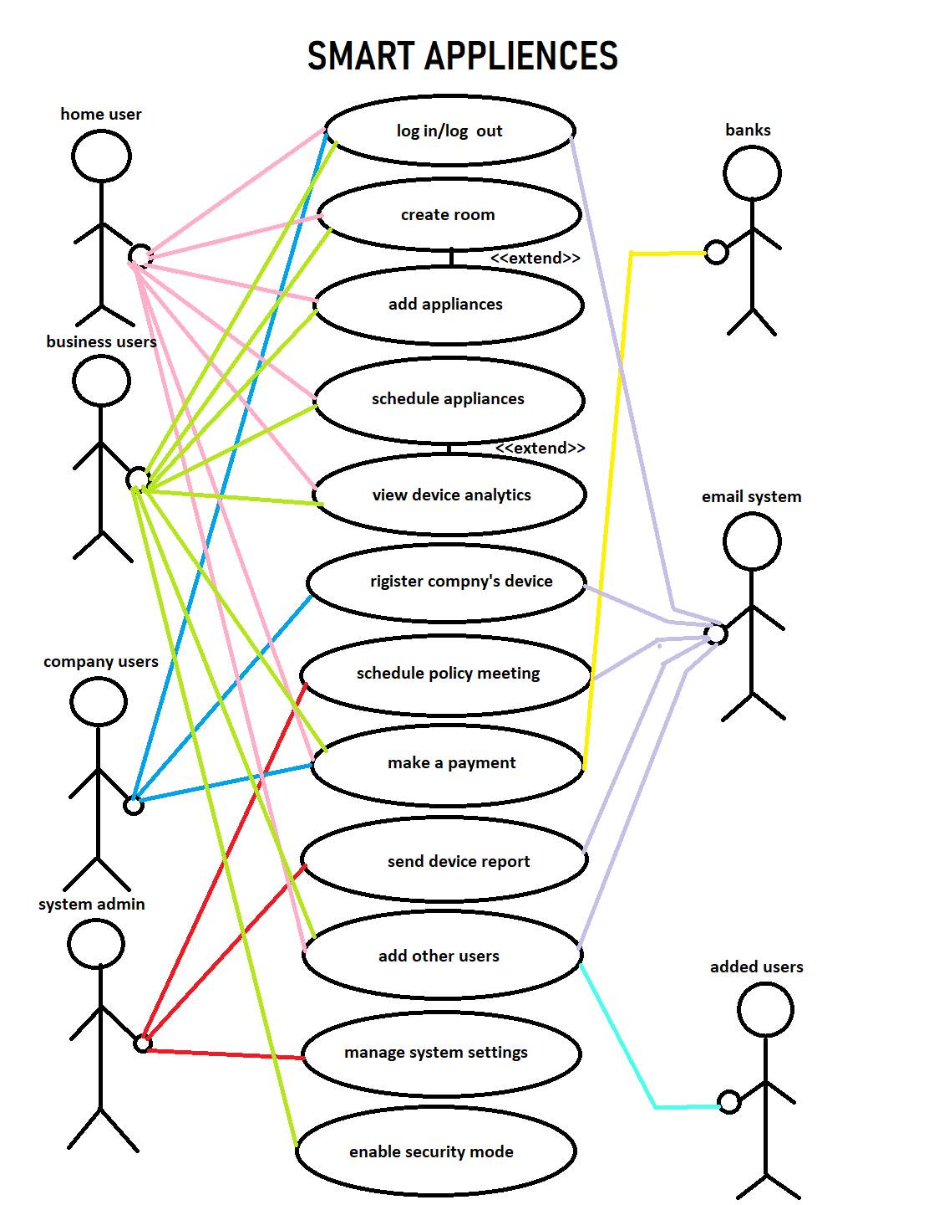

The above is a use case diagram for the entire system.

### Activity Diagrams:

**User Registartion process:**

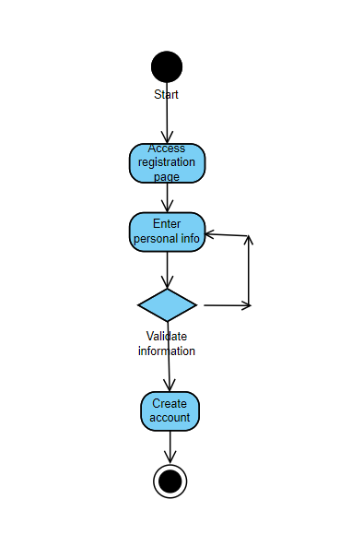

**Account Management Process:**

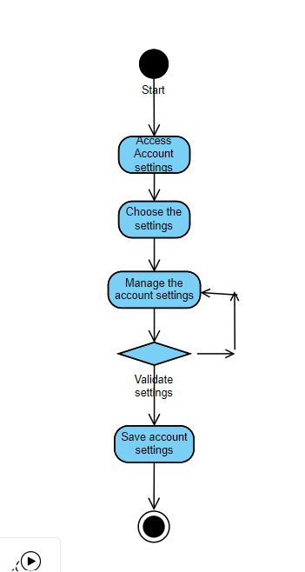

**Device Configuration settings:**

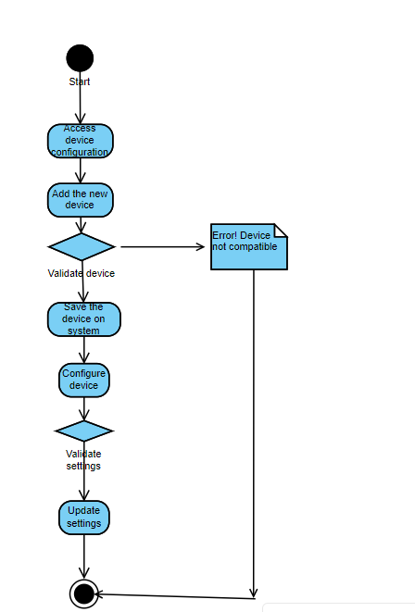

**Data collection process:**

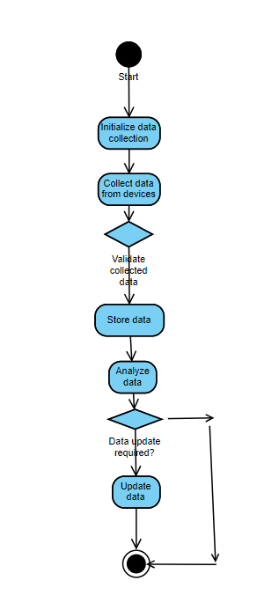

**Security mode management process:**

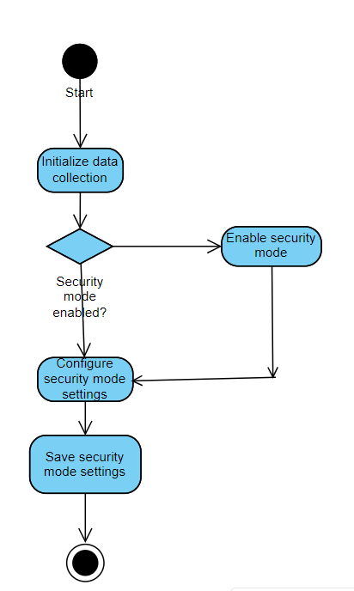

**Payment management process:**

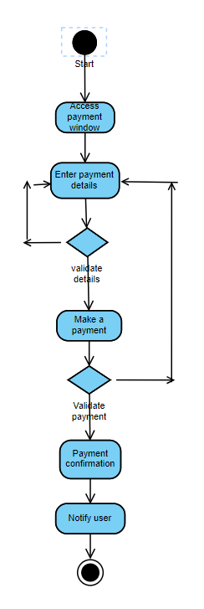

**System administrative process:**

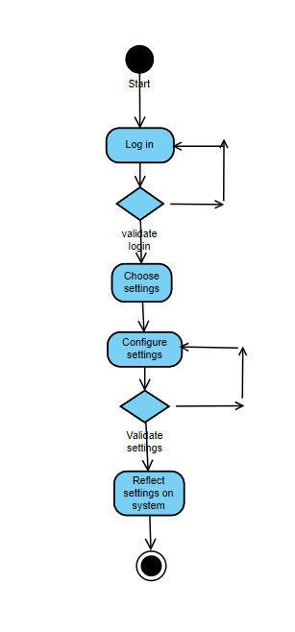

**Report Generating process:**

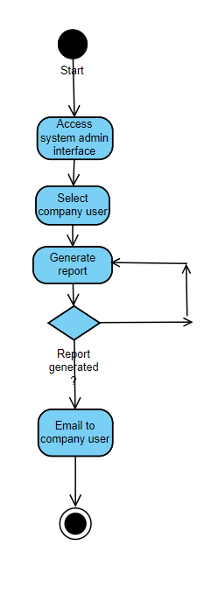

**Device Scheduling process:**

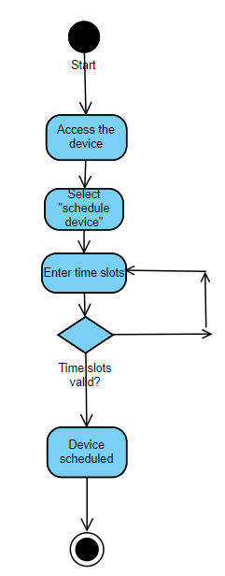

**Room creating process:**

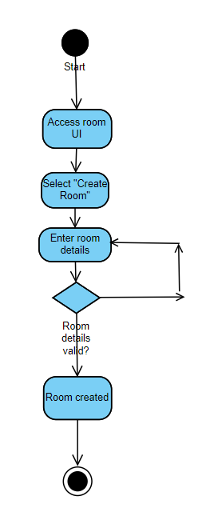

**Adding the other users:**

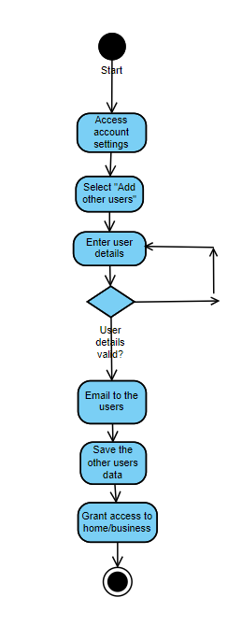

**Scheduling a policy meeting:**

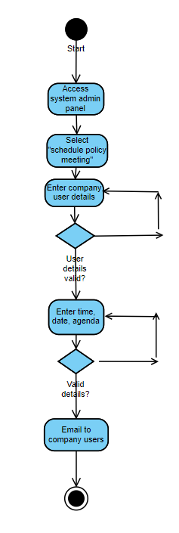

### DFD 1:

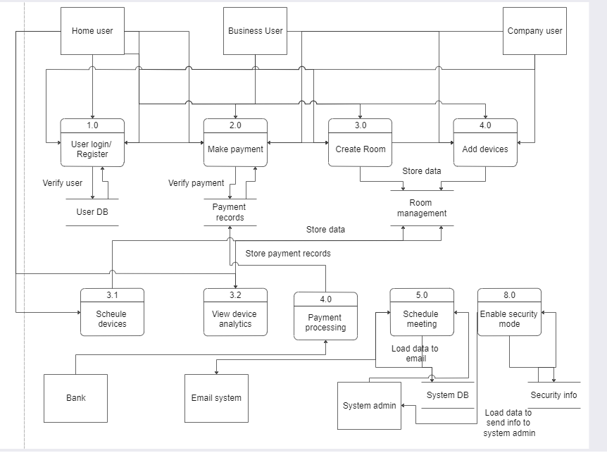

*Please ignore the minor errors of grammar or numbering.*